HOW TO EDIT/ADD OR UPDATE YOUR DIRECT DEPOSIT:

If you want to change your current direct deposit account or add a new one, please follow these steps:

****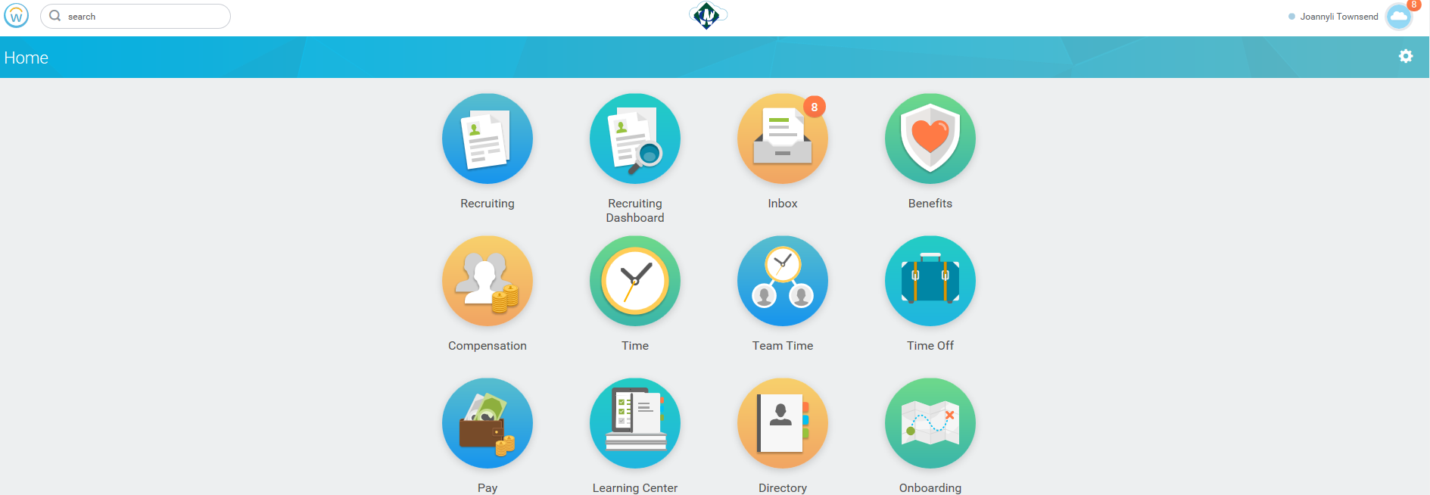

1. Log in Workday using your credentials
2. Go to Home
3. On the upper right side of the screen you will see your name, click on the cloud
4. Then choose “View profile” under your name”
5. The prior step will take you to the below screen
6. Select Pay on the header and then Payment elections

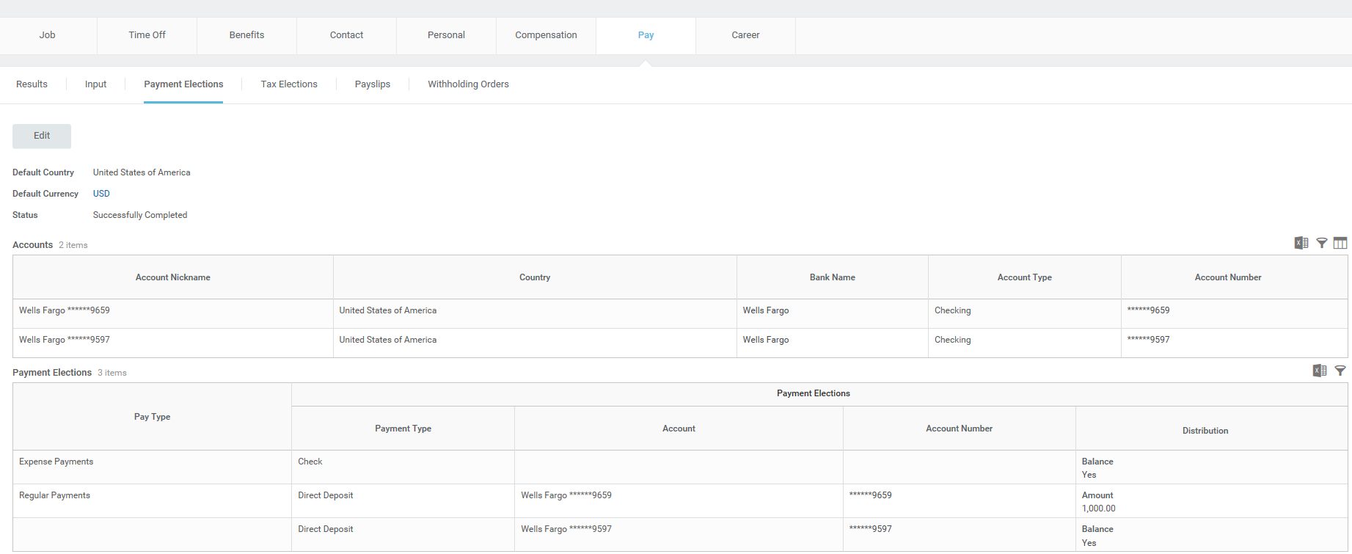

You will see all bank accounts select will populate on the screen. Here you can select as many as bank accounts you want your payroll to be paid on, the fixed amount and also the pay type. If for example, you usually report expenses, you can select these to be paid with check or in one of your accounts.

Please see screen below

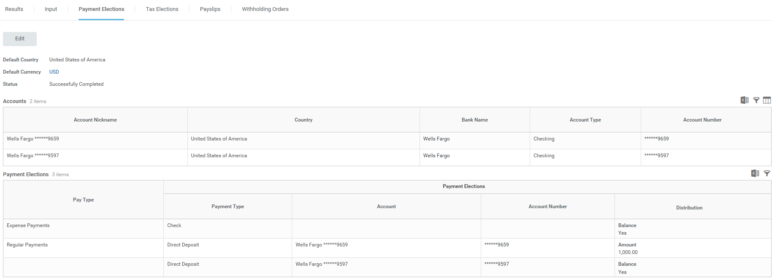

1. Click Edit and to change – add –delete your account.

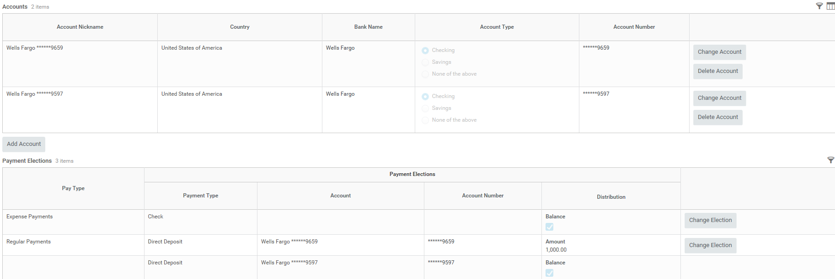

1. Remember when you select your payment elections; make sure you indicate the distribution which is how much you want to be deposited on each account. Otherwise, system will pick for you the first account and deposit the amount in full. Once you add the information click submit

***If you add a new account, be sure to have ready all information needed***

